Design and Fabrication of Micro-spiral for Specific Applications

Lokesh Kulhari, Sunil Kumar, P.K. Khanna

CSIR-Central Electronics Engineering Research Institute, Pilani-333031 (Rajasthan)
E-Mail: - slkulhari@gmail.com

Abstract
The paper presents the layout design and fabrication of micro-spiral for different applications. The contra- wound micro-spiral for helix applications are designed and fabricated in multilayer ceramics in six layers with printing line width and spacing of 350 μm and 450 μm respectively. The micro-spirals are also designed for micro-generator applications and for the inductive applications with a cavity at the center with diameter of 5 mm and printing line width and line spacing are 450 μm and 500 μm respectively.

INTRODUCTION

Low Temperature Co-fired Ceramic (LTCC) technology is a multi-layer ceramic process that can be used to fabricate low cost, high performance RF and microwave components. In this technology, passive components, such as inductors, capacitors and filters, are integrated into multilayer LTCC substrate. In LTCC, inductors may be in different form such as spiral or helical form by using different materials. Inductors can be designed as transmission line stubs. The inductor is one of the key components that determine the performance of most RF/microwave modules. Value of inductance depends on number of turns, tape thickness, position to the ground plane, line width etc [1]. The contra-wound micro-spiral Helix is a symmetry class of slom-wave circuits which has useful application in traveling-wave tubes and other related applications [2]. In this design, the current flows in clockwise and anticlockwise directions. If the clockwise currents produce effects on the axis then the anticlockwise currents flow cancels these effects produced by clockwise direction. This in-phase and out-of- phase current flow is dependent on the number of layers used in microspirals. If the number of layers is even the effects cancels while in odd number of layers the same is not true. The two modes so generated are symmetric and asymmetric.
The other micro-spiral has a cavity at the center and designed in such a way that current flows in one direction only. It removes the limitations of filament-winding method in micro-generator applications [3-4].

LAYOUT DESIGN AND FABRICATION PROCESSES

Layout design for different micro-spirals is done using Hyde software which is a flexible design system. Here design has been done for two types of micro-spirals. The first one is contra- wound micro-spiral in six layers with printing line width and spacing of 350 μm and 450 μm respectively (fig. 1). The 3 dimensional view has been shown in fig.2. The design of micro-spirals is done for 3” x 3” area with registration marks. On one substrate 12 number of micro spiral arrays have been accommodated. To provide connections to each layer simultaneously through vias, NC file is generated. The Gerber file is generated for mask preparation. In the same processes the micro-spirals with cavity are also designed for same number of layers with printing line width and spacing of 450 μm and 500 μm respectively.
In the fabrication processes the Dupont 951 green tape with the dielectric constant of 7.8 and loss tangent of 0.001 is used as substrate. In fabrication there are parallel processes for screen preparation and slitting to via filling processes on green tape (fig.3). The most important point in the fabrication of micro-spiral is the alignment of screen printed silver lines in different layers. The layers are connected simultaneously to each other through vias which are filled using via filler paste. The fabrication processes steps are shown in fig. 3. The Lamination process is done on 70 °C for 3000 psi pressure so that all individual green sheets are combined together to form one unit. Firing is done at a peak temperature of 850 °C with a time-temperature controlled firing profile (fig.4).

CONCLUSION

The contra- wound micro-spiral for helix applications with 350 μm line width and 450 μm spacing have been fabricated in multilayer. The micro-spirals with cavity are also fabricated with printing line width and spacing of 450 μm and 500 μm respectively. These spirals are useful for obtaining desired inductance by varying the number of LTCC layers and number of turns on each layer.

ACKNOWLEDGEMENT

I am thankful to Dr. Nikhil Suri, Mr. IC Sharma and all other members of HMC Group. I am also grateful to Director, CSIR-CEERI, Pilani for his guidance and permission.

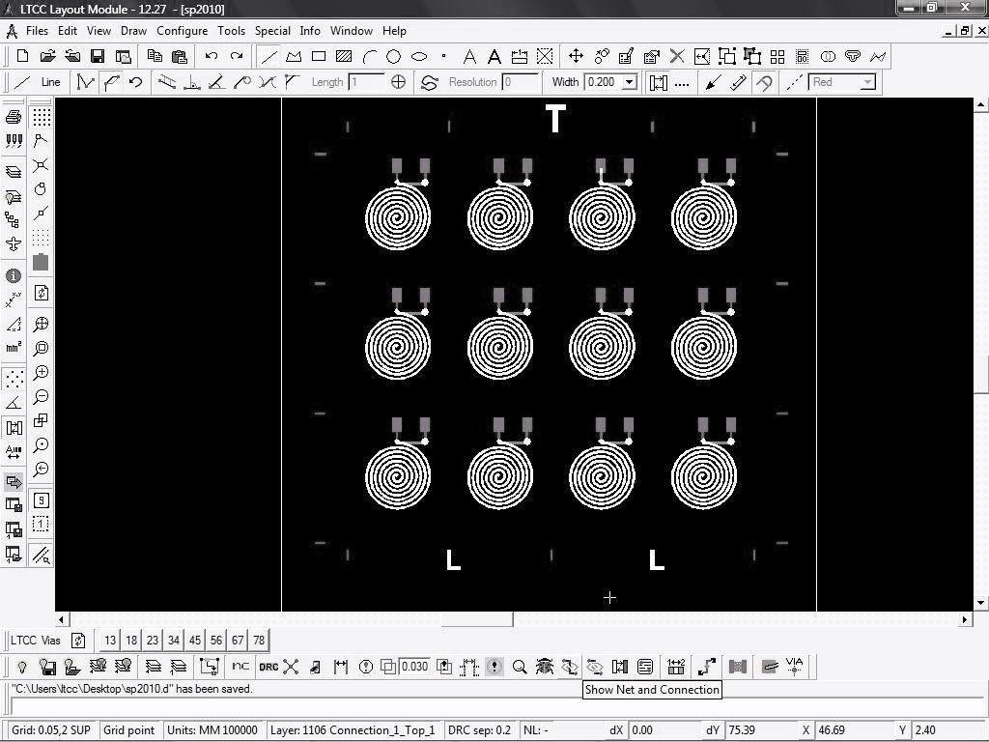
Fig. (1): Layout designing for Micro-spirals

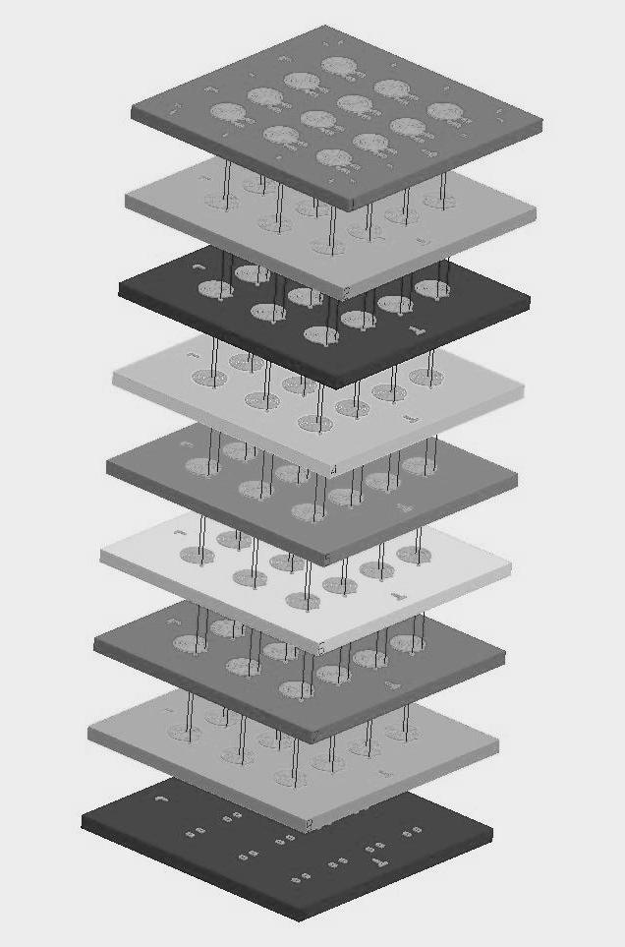

Fig. (2): 3D view for Micro-spirals

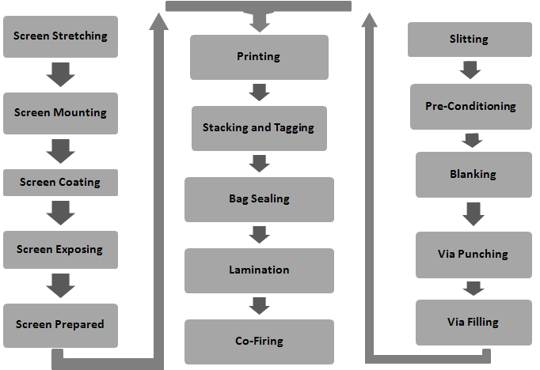

Fig. (3): Fabrication Process for Micro-spirals (Screen stretching to screen exposing are the process to prepare screen and slitting to via filling are the process to make a substrate for screen printing)
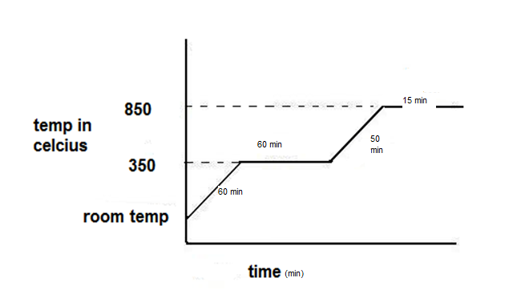
Fig. (4): Co-Firing Process for Micro-spirals

REFERENCES

- Suma M N and Suhas K”Performance Analysis and Process Parameters of Novel LTCC Filters” International Journal of Recent Trends in Engineering ,Vol 1, No. 3, May 2009
- J. E. NEVINS “An Investigation and Application of the Contrawound Helix” IRE transactions electron devices
- C T Pan and Y.J. Chen “Application of low temperature co-fire ceramics on in-plane micro-generator” Sensors and Actuators A: Physical Volume 144, Issue 1, 28 May 2008, Pages 144-153.
- H. Matsuki, N. Fujii, K. Shirakawa, J. Toriu, and K. Murakami, “Magnetic-multi-turn planar coil inductor,” IEEE Trans. Magn., vol. 27, pp. 5438–5440, Nov. 1991.

