Dielectric measurements of coolant materials used in gyrotron window
Nitin Kumar, Vivek Yadav, Udaybir Singh, Anil Kumar and AK Sinha
Gyrotron Laboratory, Microwave Tube Area
CSIR-Central Electronics Engineering Research Institute (CEERI)
Pilani, Rajasthan, INDIA-333031

E-mail: nitingkv@gmail.com

Abstract: Gyrotron is a high power, high frequency millimeter wave source based on the phenomena called Cyclotron Resonance Maser (CRM) instability occurring during the interaction of the helically moving electrons with RF. Gyrotron lead variety of features such as technological, scientific and industrial applications, mainly for heating of plasmas at nuclear fusion installations and high temperature processing of materials. RF window happens to be the most critical and vulnerable component in any high power microwave/mm wave vacuum device, which limits its power handling capability. The RF loss in the RF window directly depends on the material dielectric properties. Considering the minimum RF losses and maximum RF transmission (ideally 100 %), various low loss dielectric materials, like, BN, Sapphire, AlN, CVD diamond, etc, are explored specifically for the gyrotron applications. Different kinds of window cooling schemes can be adopted depending on the material thermal properties. For 42 GHz, 200 kW gyrotron, double disk sapphire widow with specific coolant liquid is adopted. The dielectric properties of coolant materials play a crucial role in the design and fabrication of RF window. In this article, the results of dielectric properties measurements of different coolant materials such as FC-75, FC-40 and CCl₄ are presented and discussed. Figs. 1 and 2 show the measurement results of all three coolant materials up to 50 GHz frequency.
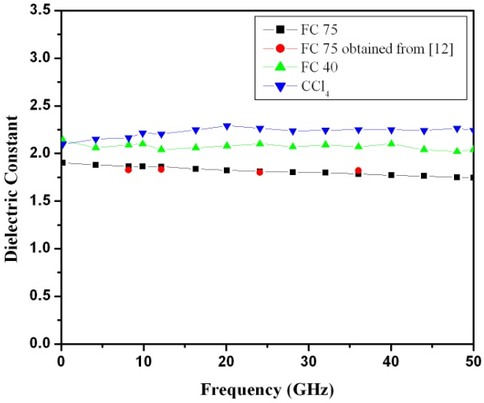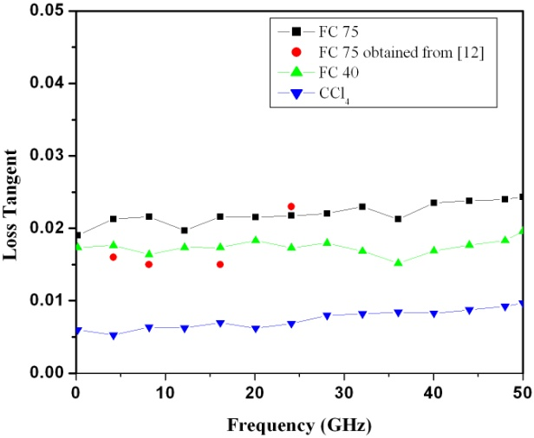

Fig. 1: Dielectric constant with respect to frequency Fig. 2: Loss tangent with respect to frequency

